- Enumeration
- FTP Enumeration (Port 21)
use commands: ftp 150.1.7.102
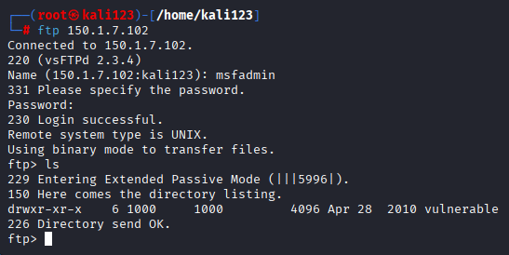
Directory listing and login attempt was successful from ftp port.

- SMB Enumeration (Port 139/445)
Command use: enum4linux -a 150.1.7.102
Enumerated Users:
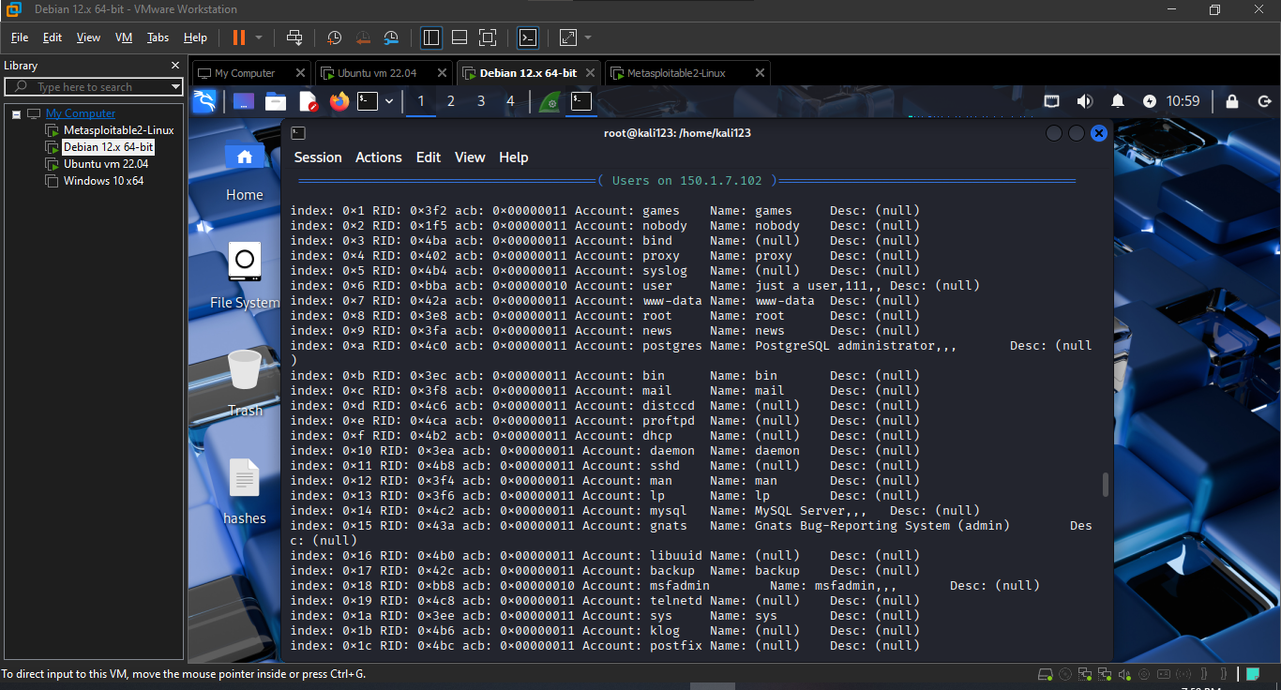
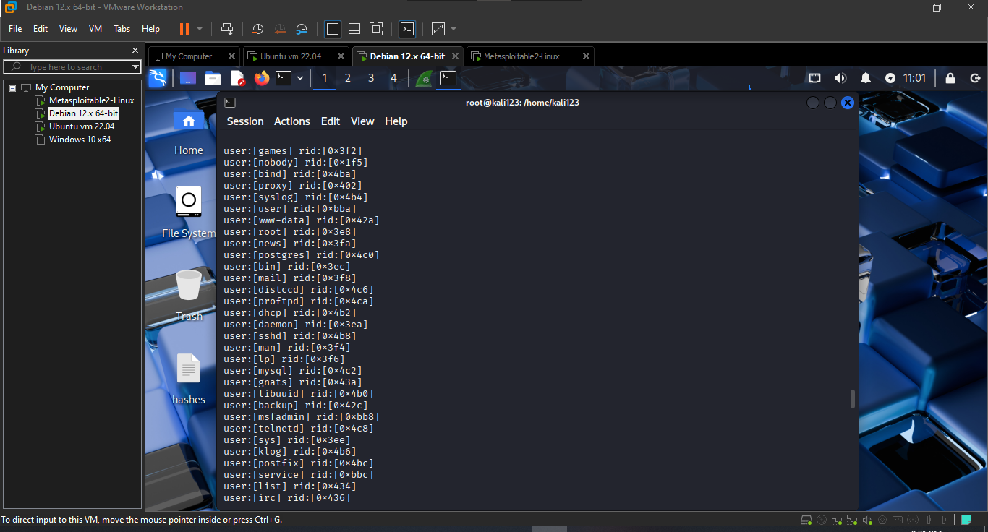
Shared folders:
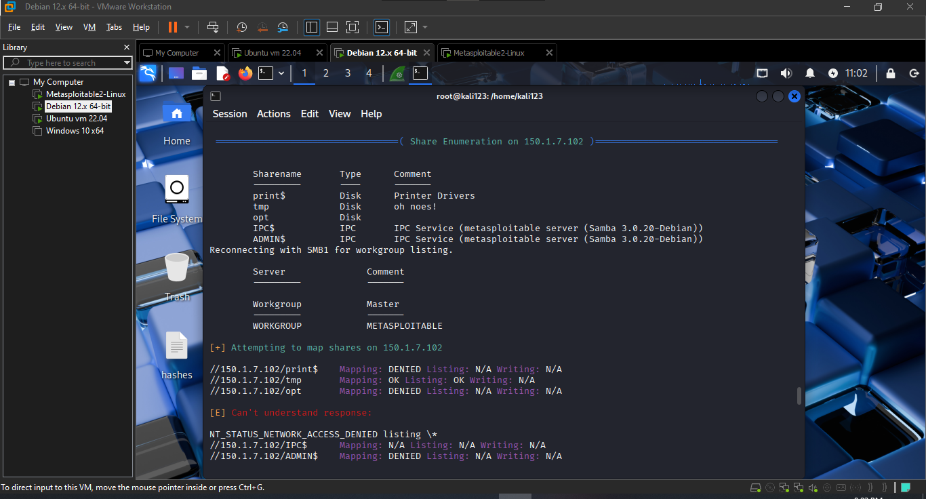
OS info
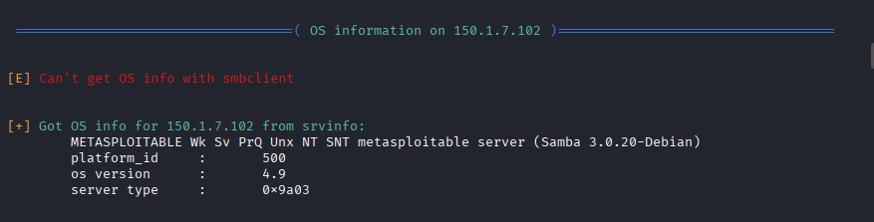
Workgroup info
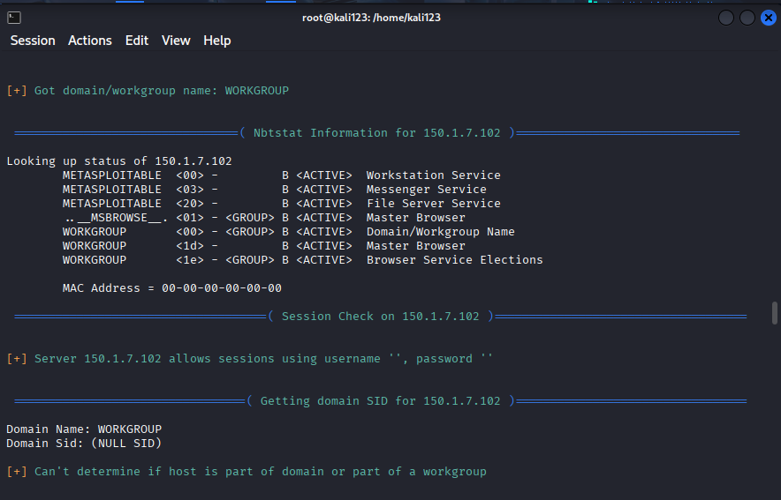

- HTTP Enumeration (Port 80)
Command used: http://150.1.7.102 for preview of webpage
The homepage of the target website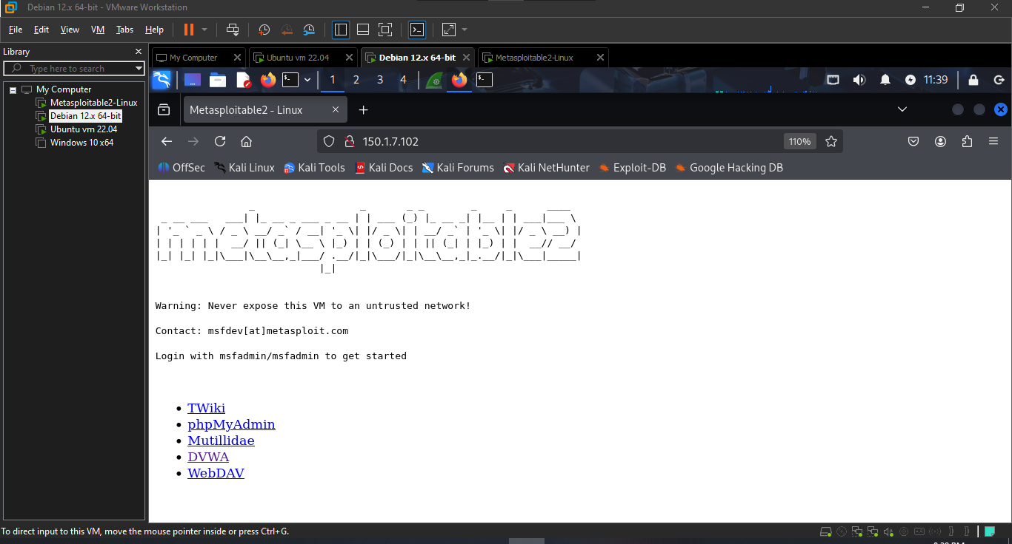
Command used: nikto –h http://150.1.7.102
Server banner (e.g., Apache version)
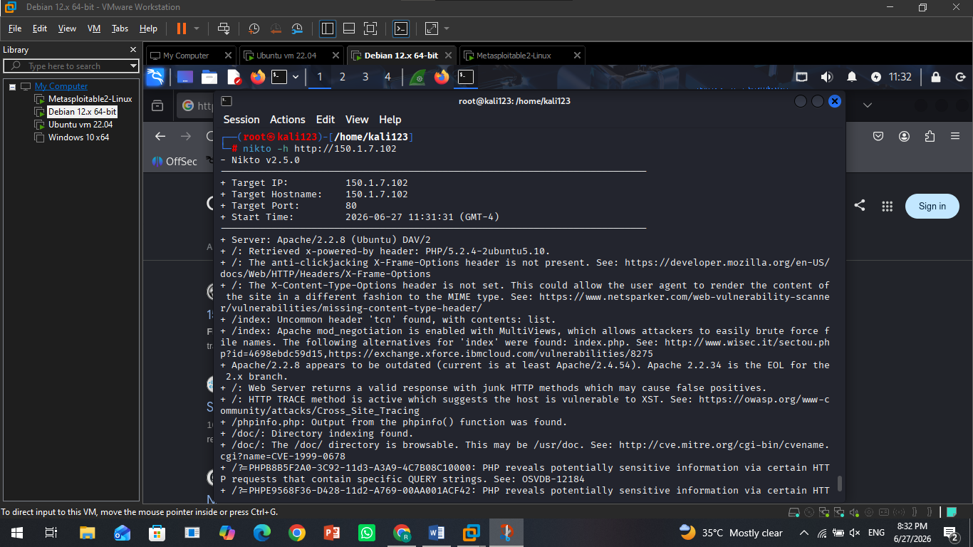
- Telnet Enumeration (Port 23)
Command used telnet 150.1.7.102

